

Southern Luzon State University
COLLEGE OF ENGINEERING
Computer Engineering Department
Lucban, Quezon

CPE22L: Digital Signal Processing Laboratory

Activity # 1: Introduction to MATLAB

PADUADA, Dave Jhared G.

DOP: September 5, 2025
DOS: September 10, 2025

RATING

Engr. Ralph Monsour Delima
INSTRUCTOR

CPE22L – Digital Signal Processing
Laboratory # 1

- Objectives
  - To be familiarized with the MATLAB software – its use and functions.
  - To learn how to use the basic commands of MATLAB
  - To perform and analyze basic operations included in MATLAB

- MATLAB is a powerful high-level programming language for scientific computations. It is very easy to learn and use in solving numerically complex engineering problems. The exercises in this book have been written assuming you are not proficient in MATLAB.
However, some basic concepts of MATLAB are included here for a quick review to facilitate your understanding of the programs and for performing the exercises.
MATLAB consists of functions that are either built into the interpreter or available as M-files, with each containing a sequence of program statements that execute a certain algorithm. A completely new algorithm can be written as a program containing only a few of these functions and can be saved as another M-file.
MATLAB works with three types of windows on your computer screen. These are the Command window, the Figure window, and the Editor window. The Command window has the heading Command, the Figure window has the heading Figure No. 1, and the Editor window has the heading showing the name of an opened existing M-file or Untitled if it is a new M-file under construction. The Command window also shows the prompt >> indicating it is ready to execute MATLAB commands. Results of most printing commands are displayed in the Command window. This window can also be used to run small programs and saved M-files. All plots generated by the plotting commands appear in a Figure window. Either new M-files or old M-files are run from the Command window. Existing M-files can also be run from the Command window by typing the name of the file.
In our activity, we illustrate the use of some of the most used functions and review some fundamental concepts associated with MATLAB.

III. Procedures & IV. Data and Results
1.1 Number & Data Representation
Problem | Answer | Explanations
1.1.1.  X=[1 2 3 4; 5 6 7 8; 9 10 11 12]; | 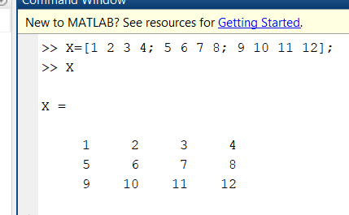 | Defines a 3×4 matrix with integer values.
Y = [1+2∗i,3−4∗i,5+6∗i; 7−8∗i,9+10∗i,11−12∗i]; | 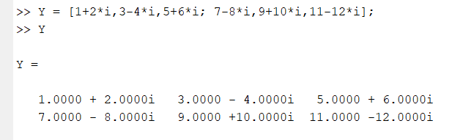 | Creates a 2×3 matrix of complex numbers.
1.2 Arithmetic Operations
1.2.1.  1) Let X = [1 2 3; 4 5 6] and Y =[12 11 10; 9 8 7].  Find  - a. X+Y | 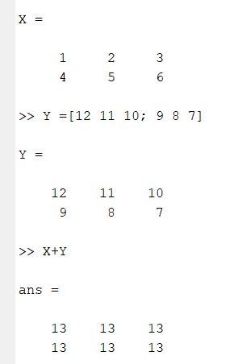 | adds elements by position (e.g., X(1,1)+Y(1,1))
- b. X−Y | 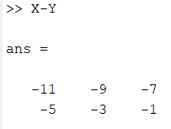 | subtracts elements by position (e.g., X(2,3)−Y(2,3)).
- c. X+3 | 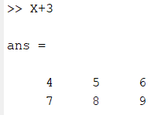 | adds 3 to every element (e.g., X(1,2)+3).
- d. X∗Y′ | 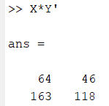 | multiplies rows of X with columns of Y (matrix product, 2×2).
- e. X’∗Y | 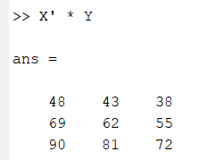 | multiplies columns of X with columns of Y (matrix product, 3×3).
2)  - Consider the two matrices X = [1 2 3; 4 5 6; 7 8 9] and Y = [1 1 2; 2 2 3; 1 3 4].  Solve  - a. X/Y | 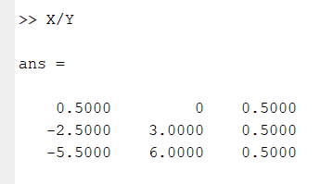 | right division: multiplies X with inverse of Y → solves Z*Y = X.
- b. Y\X | 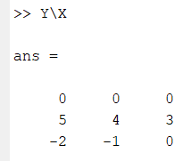 | left division: multiplies inverse of Y with X → solves Y*Z = X.
1.3 Relational Operators
1.3.1.  Consider the two matrices C = [1 2 3; 4 5 6] and D = [1 7 2; 6 5 1]. Using relational operators in MATLAB. a. C < D  Find:  - a. C < D | 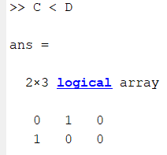 | compares element by element (e.g., C(1,2) < D(1,2)).
- b. C>D | 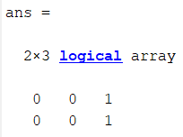 | true if X element is greater (e.g., C(2,1) > D(2,1)).
- c. C<=D | 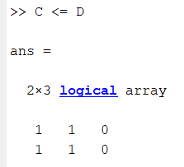 | checks if less or equal per index.
- d. C==D | 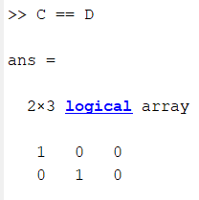 | true if same value at same index (e.g., C(2,2)==D(2,2)).
- e. C~=D | 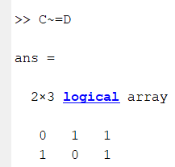 | true if values differ at same index.
1.4 Logical Operators
1.4.1.  Consider the two matrices A = [1 1 0 1] and B = [0 1 0 0]. Find the results of applying the above logical operators on A and B.  - a. A&B | 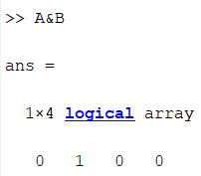 | element-wise logical AND (1 only where both are 1).
- b. A|B | 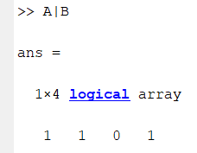 | element-wise logical OR (1 where either is 1).
- c. ~A | 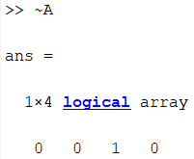 | logical NOT, flips 1→0 and 0→1 in A.
- d. ~B | 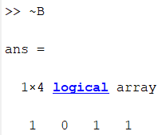 | logical NOT, flips 1→0 and 0→1 in B.
1.5 Control Flow
1.5.1.  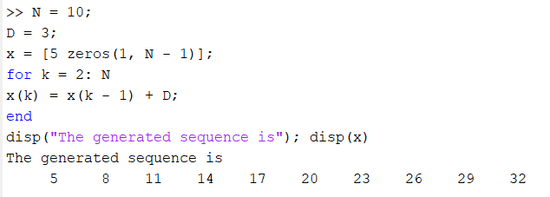  N = 10;  D = 3;  x = [5 zeros(1,N−1)]; for k = 2:N  x(k) = x(k−1) + D; end  disp(’The generated sequence is’);disp(x) |  | For loop adds D=3 to the previous element, generating an increasing sequence of length N.
1.5.2.  N = 15; D = 3;  x = [5 zeros(1, N − 1)];  for k = 2: N  x(k) = x(k − 1) + D;  if x(k) == 3∗D + x(1)  D = −abs(D);  elseif x(k) == x(1)  D = abs(D);  end  end disp(“The generated sequence is”);  disp(x) | 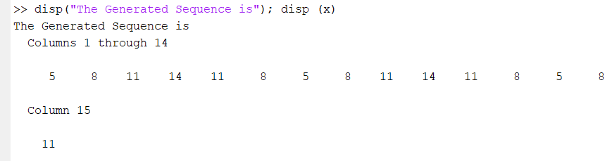 | Sequence increases by D=3 until reaching 14, then D flips negative to decrease back to 5, creating an up & down repeating pattern.
1.5.3.  y = 5; D = 3;  while 1  y = y + D;  if y > 100,break,end  end  disp(’y is’); disp(y) | 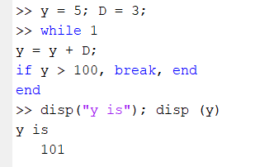 | While loop keeps adding D=3 until value exceeds 100; break stops the loop once condition is met.
1.6 M-Files: Scripts & Functions
% Script M-file lowpass.m  % Program to Perform Lowpass Filtering  % Using Three-Point Averaging of a Random Signal  % Program uses the function file runsum  z = zeros(1,11);data = randn(size(z));  u = [zeros(1,3) data];  N = 3; % N is the filter length  for k = 1:10;  w = u(k:k+N);  z(k) = runsum(w);  end  n = 0:10;  % Plot the noise in solid line and  % the smoothed version in dashed line  plot(n,data,’r-‘,n,z,’b--’);grid  xlabel(’Time index n’);  ylabel(’Amplitude’);  gtext(’Noisy data’);gtext(’Smoothed data’); | 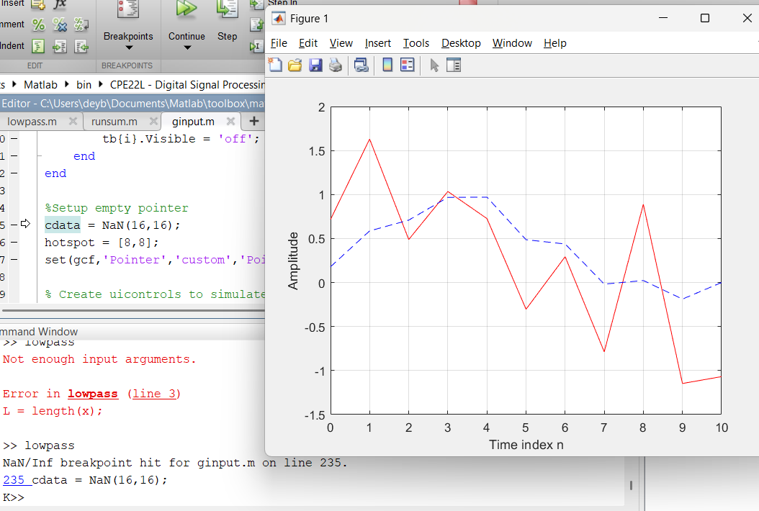 | Function file:  Defines a function file that computes the average of input vector x. Variables are local.  Script file:  Script file uses runsum to smooth noisy data with 3-point averaging, then plots original vs. filtered signal.

V. Conclusion

In this lab activity, I was able to explore the basics of MATLAB and understand how it can be used in digital signal processing. I learned how to work with matrices using arithmetic, relational, and logical operations, and I also saw how loops and conditions control the flow of a program. Writing simple M-files helped me see the difference between scripts and functions, and how they can be used together to make programs more organized. The plotting part also showed me how signals can be visualized clearly in MATLAB. Overall, this activity helped me become more familiar with MATLAB and gave me a good starting point for applying it in DSP.

